**1.** Consider the problem of finding the shortest path between two points on a plane that has

convex polygonal obstacles as shown in Figure1. This is an idealization of the problem

that a robot has to solve to navigate in a crowded environment.

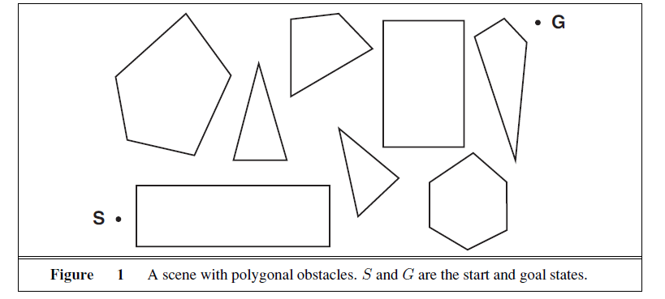

**a**. Suppose the state space consists of all positions (x, y) in the plane. How many states

are there? How many paths are there to the goal?

**b**. Explain briefly why the shortest path from one polygon vertex to any other in the scene

must consist of straight-line segments joining some of the vertices of the polygons.

Define a good state space now. How large is this state space?

**2** Consider a state space where the start state is number 1 and each state k has two

successors: numbers 2k and 2k + 1.

**a**. Draw the portion of the state space for states 1 to 15.

**b**. Suppose the goal state is 11. List the order in which nodes will be visited for breadthfirst

search, depth-limited search with limit 3, and iterative deepening search.

**c**. Call the action going from k to 2k Left, and the action going to 2k + 1 Right. Can you

find an algorithm that outputs the solution to this problem without any search at all?

3) True or false: If decision tree D2 is an elaboration of tree D1, then D1 is more-general-than D2. Assume D1 and D2 are decision trees representing arbitrary boolean functions, and that D2 is an elaboration of D1 if ID3 could extend D1 into D2. If true, give a proof; if false, a counterexample.

1. **Prove the optimality of A* informed search algorithm.**

**5)** Study the following table and construct a decision tree for computer buying behaviour prediction **using Information Gain as the heuristics**.

1. Express the **decision tree as a rule**.
2. Apart from the Decision Tree that you got, provide **one more Consistent hypothesis** for this set pf samples provided.

|  |  |  |  |  |  |  |
| --- | --- | --- | --- | --- | --- | --- |
| **No** | **Age** | **Income** | **Type** | **Family income** | **Credit Rating** | **Buys computer** |
| 1 | 25 | High | Employee | 20000 | Low | No |
| 2 | 24 | High | Employee | 21000 | Low | No |
| 3 | 32 | High | Employee | 15000 | High | No |
| 4 | 41 | Medium | Employee | 36000 | High | Yes |
| 5 | 42 | Low | Student | 36500 | High | Yes |
| 6 | 43 | Low | Student | 38000 | High | No |
| 7 | 40 | Low | Student | 35000 | High | Yes |
| 8 | 26 | Medium | Employee | 18000 | Low | No |
| 9 | 30 | Low | Student | 31000 | Low | No |
| 10 | 42 | Medium | Student | 37000 | High | Yes |
| 11 | 25 | Medium | Student | 19000 | Low | No |
| 12 | 35 | Medium | Employee | 18000 | High | No |
| 13 | 38 | High | Student | **34000** | High | Yes |
| 14 | 45 | Medium | Employee | 51000 | High | No |

**6) For the above problem,**

1. Calculate the instance space size
2. No of semantically different hypothesis
3. No of syntactically different hypothesis
4. Size of concept space